DAY 3 LAB PROGRAMS

1.You are given a map with regions (represented as nodes or vertices) that need to be colored such that no adjacent regions have the same color. The goal is to find a valid coloring for the entire map. Implement in graph using Python.”

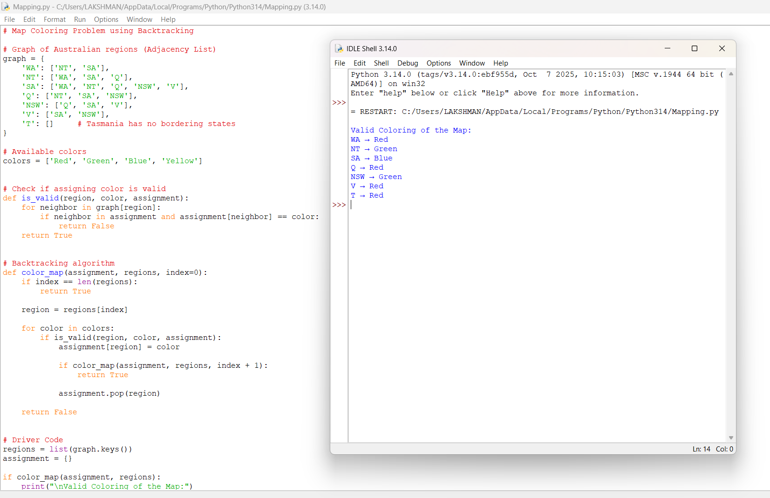

2.Given a list of cities and the distances between each pair of cities, the objective is to find the shortest possible route that visits each city exactly once and returns to the original city (the salesman’s starting point). Implement the scenario using Python.

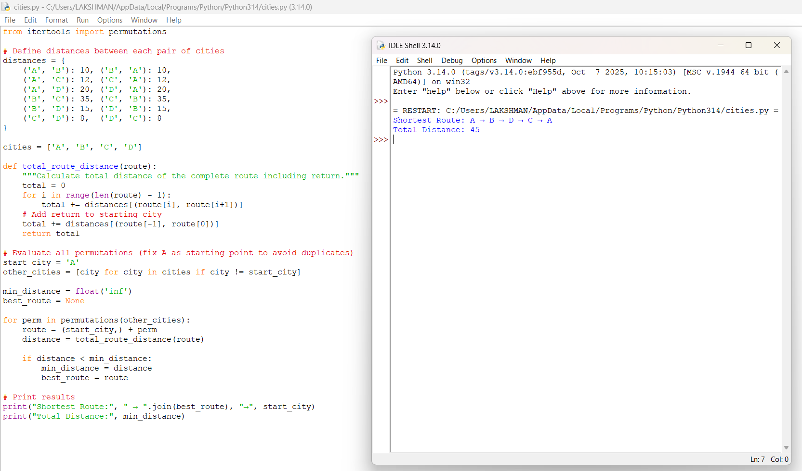

3.Implement a Python program to solve the Knight’s Tour problem using backtracking.
The program should:
a) Represent the chessboard as an N×N grid.
b) Place the knight on a starting square.
c) Recursively attempt to move the knight to all unvisited squares.
d) Backtrack when no legal moves are available.
e) Print the final path if a full tour is found, or report failure otherwise.”

